Table of Contents

Online Literary Management System 1

1 Introduction 1

2 Problem Statement 2

3 Objectives 2

4 Methodology 2

a. Requirement Identification: 5

i. Study of existing systems: 5

ii. Requirement collection: 5

b. Feasibility Study: 5

i. Technical Feasibility: 5

ii. Operational Feasibility: 6

iii. Economic Feasibility: 6

c. High-Level Design of System: 7

i. System Flowchart 7

ii. Methodology of the Proposed System 8

iii. Working Mechanism of the Proposed System 8

5 Gantt Chart 9

6 Expected Outcome 10

7 References 10

# 

# Online Literary Management System

# Introduction

In the world of literature, novels have long captivated readers with their immersive narratives and diverse genres. With the advent of the digital age, novels have found a new platform in the form of web novels, offering a convenient and accessible way to engage with literary works. To enhance the reading experience and guide users towards their desired literary preferences, novel management systems play a crucial role.

This proposal outlines the development of an Online Literary Management System designed to empower users with the tools they need to organize their digital libraries with ease. This system will prioritize user-friendliness, flexibility, and essential functionalities, making it suitable for a wide audience.

# Problem Statement

The ever-expanding landscape of online literary content presents a challenge for users in managing their personal libraries. Existing management solutions may lack user-friendliness, require advanced technical skills, or lack essential functionalities, making them unsuitable for a wide audience. This project addresses these limitations by creating a user-centric system tailored to individual needs and preferences.

# Objectives

The Online Literary Management System aims to:

* Offer an intuitive user interface: Prioritize user-friendliness and intuitive navigation for seamless interaction.
* Implement comprehensive CRUD functionalities: Integrate Create, Read, Update, and Delete functions for effective content management.
* Enable flexible organization: Allow users to personalize their libraries through categorization, tagging, and custom sorting options.
* Ensure wide compatibility: Support various formats of online literary resources, offering a comprehensive solution.

# Methodology

This proposal outlines a novel management system employing the Spiral Methodology for continuous improvement and user-centric development. This approach allows for early risk identification and mitigation, ensuring the system evolves to meet user needs and preferences.

Key Benefits of the Spiral Methodology:

* Progressive Development: The Spiral Model's iterative approach lets us build the system in manageable parts, prioritizing features based on user feedback and ensuring all needs are addressed. This avoids overwhelming users with complex functions at once and gives them a say in the development process.
* Cost Control and Improved Estimates: By incrementally adding features and testing them early, we can refine cost estimates throughout development. This minimizes the risk of exceeding budgets and ensures resources are allocated effectively, ultimately leading to a system that delivers the most value to users within budget constraints.
* Adaptability to Changing Needs: User preferences and literary content trends can evolve, but the Spiral Model's flexibility allows us to easily incorporate changes and updates based on ongoing user feedback. This keeps the system relevant and responsive to their evolving needs, enhancing user satisfaction and engagement.
* Continuous Risk Mitigation: Every phase of the Spiral Model prioritizes risk analysis and mitigation. This proactively addresses potential security vulnerabilities, bugs, or functional issues that could impact user experience. By tackling these risks early and iteratively, we ensure a more stable and secure system for our users.
* Early Customer Engagement: Throughout the development cycle, users are included in evaluations and prototypes. This encourages open communication and transparency, allowing users to see the system progress and provide feedback at every stage. This not only ensures the final product aligns with their expectations but also creates a sense of ownership and investment in the system. [1]

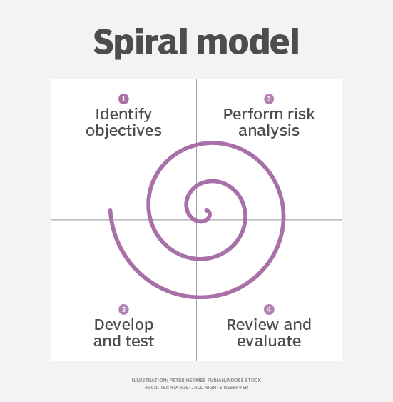

Figure: Spiral Model

System Development Activities:

Phase 1: Planning & Requirements

Define System Objectives & Functionalities: Clearly establish the system's core purpose and key features.

Identify & Analyze Requirements: Through user interactions, gather and refine detailed system requirements.

Evaluate Alternative Solutions: Assess potential approaches, analyzing their advantages and disadvantages.

Phase 2: Risk Assessment & Prototype Development

Perform Comprehensive Risk Analysis: Identify and prioritize potential risks associated with each proposed solution.

Develop Initial Prototype: Implement a fundamental version of the system based on the selected approach.

Conduct Rigorous Testing: Evaluate the prototype's performance and functionality through thorough testing procedures.

Phase 3: Evaluation & Refinement

Analyze Test Results & User Feedback: Assess the prototype's strengths and weaknesses, incorporating user insights.

Refine System Design & Functionalities: Modify the system based on the gathered data, optimizing performance and features.

Plan for Next Iteration: Define the goals and scope of the next development phase, incorporating adjustments.

Phase 4: Iteration & Deployment

Repeat Phases 1-3: Continue through the planning, risk assessment, prototyping, and evaluation cycle until the system meets desired standards.

Final System Construction & Testing: Implement the final version of the system based on the refined prototype.

Deployment & Ongoing Maintenance: Release the system to users and provide ongoing support and maintenance to ensure continued success.

## Requirement Identification:

1. Study of existing systems: We will analyze strengths and weaknesses of existing management solutions to identify opportunities for improvement.
2. Requirement collection: We will gather user feedback through surveys and interviews to understand user needs and desired functionalities.
3. **Feasibility Study**

### Technical Feasibility:

We will leverage our existing skillset in front-end (HTML5, CSS3, JavaScript) and back-end (PHP) technologies to maximize efficiency and development speed.

We will utilize readily available and beginner-friendly frameworks like Bootstrap or Django for rapid development.

We will explore online communities and documentation resources for frameworks and chosen tools. We will also consider reaching out to other students or faculty members for expert guidance when needed.

We will choose a free web hosting platform like GitHub Pages or Google Cloud Platform Free Tier to avoid hosting costs.

### Operational Feasibility:

We will prioritize developing essential features within the semester timeframe, focusing on features achievable with available resources and skills.

We will assign development tasks based on strengths and skill levels, utilizing the supervisor's expertise for guidance and code review.

We will implement tools like Git for version control and collaborative development, allowing for easy tracking of progress and changes.

### Economic Feasibility:

We will analyze how the project aligns with learning objectives and course requirements, justifying time commitment and prioritizing tasks that contribute to academic goals.

We will showcase the project's potential to learn new skills, gain practical experience, and contribute to the learning community.

## High-Level Design of System:

### System Flowchart

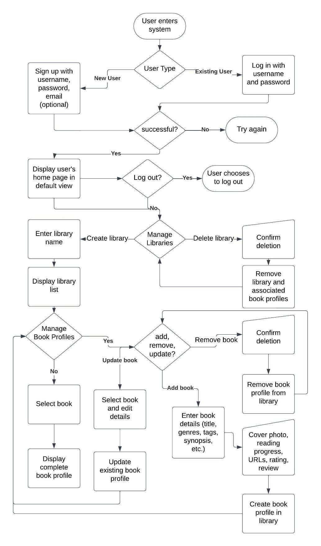

Fig. System Flowchart

### Methodology of the Proposed System

Technologies and Frameworks:

Front-end: HTML5, CSS3, and JavaScript will create a responsive and user-friendly interface accessible across various devices. A lightweight framework, yet to be determined, will streamline development and maintainability.

Back-end: PHP will handle server-side logic, user authentication, and database interactions.

Database: MySQL or MariaDB will efficiently store and manage book profiles, user preferences, and system settings.

Data Management Strategy:

Centralized Storage: Book profiles, including titles, genres, tags, synopses, cover photos (optional), reading progress, URLs, ratings, and reviews, will be stored in the database.

Indexing and Retrieval: Efficient indexing mechanisms will facilitate fast searching, filtering, and sorting of books within user libraries.

Privacy Focus: Only minimal user information (usernames, passwords, and optional email addresses) will be stored to prioritize privacy.

Development Stages:

Spiral Methodology: Iterative development with continuous feedback will guide the project.

Feedback Sources: Primary feedback will come from students and supervising teachers involved in development, with potential for limited feedback from other students.

Condensed Timeline: Prototyping, functional implementation, testing, and deployment will be condensed to achieve completion within one month.

### Working Mechanism of the Proposed System

User Interface Design:

Intuitive Navigation: Clear menus and content organization will promote effortless exploration.

Customizable Views: Users can personalize how their libraries are displayed (e.g., alphabetical, by genre, by reading progress).

Search and Filters: Robust search functionality and filtering options will enable quick content discovery.

Content Management Features:

Library Creation: Users can create multiple libraries to categorize their literary collections.

Book Profiles: Comprehensive book profiles will store essential details, enabling users to track progress, store links, and add personal ratings and reviews.

CRUD Functionality: Users can create, read, update, and delete book profiles within their libraries.

Offline Access: Library viewing and modification will be possible offline, with changes taking effect upon reconnection.

Security and Privacy:

Basic Protection: Password-protected accounts and restricted access will safeguard user data.

Privacy Emphasis: The system's primary focus is functionality and user experience within a mock project setting; therefore, advanced security measures are not currently prioritized.

# Gantt Chart

Table: Time Schedule

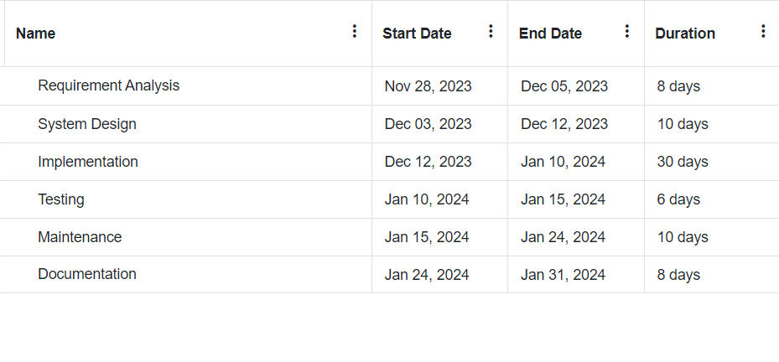

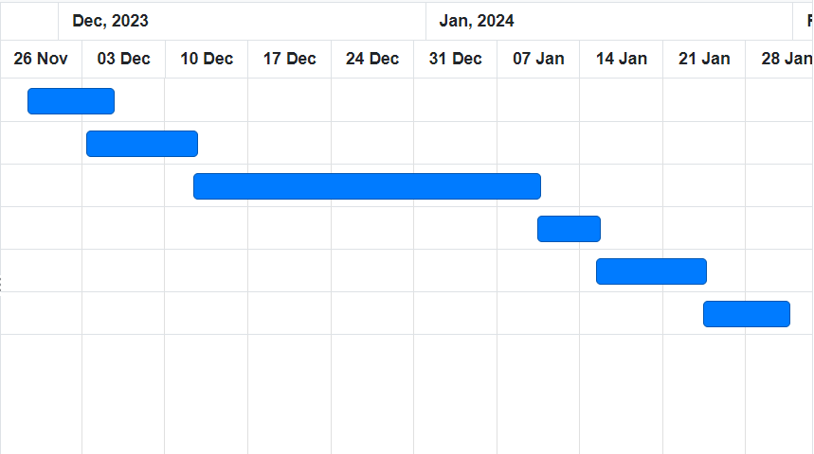

Figure: Gantt Chart

# Expected Outcome

The Online Literary Management System is expected to:

* Enhance user experience with efficient and personalized library management.
* Increase discoverability of desired literary content within personal collections.
* Demonstrate the feasibility of creating a user-centric and functionally rich system.

# References

|  |  |
| --- | --- |
| [1] | T. Contributor, "What is Spiral Model?," Tech Target, August 2019. [Online]. Available: https://www.techtarget.com/searchsoftwarequality/definition/spiral-model#:~:text=The%20spiral%20model%20is%20a,elements%20of%20the%20Waterfall%20model.. [Accessed 15 December 2023]. |
| [2] |  |